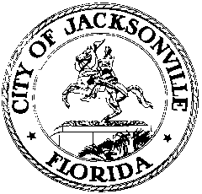

OFFICE OF THE CITY COUNCIL

117 WEST DUVAL STREET, SUITE 425
4TH FLOOR, CITY HALL
JACKSONVILLE, FLORIDA 32202
904-630-1377

CIVIL RIGHTS HISTORY MARKETING MINUTES
Committee Room B, 1st Floor, City Hall
May 8, 2018
10:00 a.m.

Location: Committee Room B, 1st floor, City Hall – St. James Building, 117 West Duval Street

In attendance: Tony Allegretti (Co-Chair)

Also: Yvonne P. Mitchell – Council Research Division

Meeting Convened: 10:04 a.m.

Mr. Tony Allegretti, Co-Chair, convened the meeting. There were no other members or visitors present. Mr. Allegretti stated he would provide comments at the Task Force meeting. No other information provided.

Meeting adjourned: 10:15 a.m.

Minutes: Yvonne P. Mitchell, Council Research
Posted 05.04.18 9:30 p.m.

